**eCom Store**

**Introduction**

eCom is a website for selling female clothes online. It allows the site administrator to post products on the website, which customers can view on the front-end. A customer can view the details of a product and order if interested.

**Target Audience**

The target audience of the website is ladies, those interested in fashion. Ladies love to be smartly dressed and they shop clothes more often than men. eCom Store only sells ladies clothes.

**Design Goals**

1. Brand Image

We want our website to be a replica of the eCom Store brand and everything it stands for.

2. Layout

We would like to keep our website very neat and simple. We will structure the layout so that it brings attention to the most essential areas of the website.

3. Font And Typography

We will use a nice and visible font that represents our brand identity and use catchy text to keep the customer interested.

4. Site Navigation

We want to create a good customer experience with easy site navigation which will convert to sales.

5. Customer Service

We should provide a easy way for customers to reach us through the website.

**Flow Chart**

Admin Flowchart

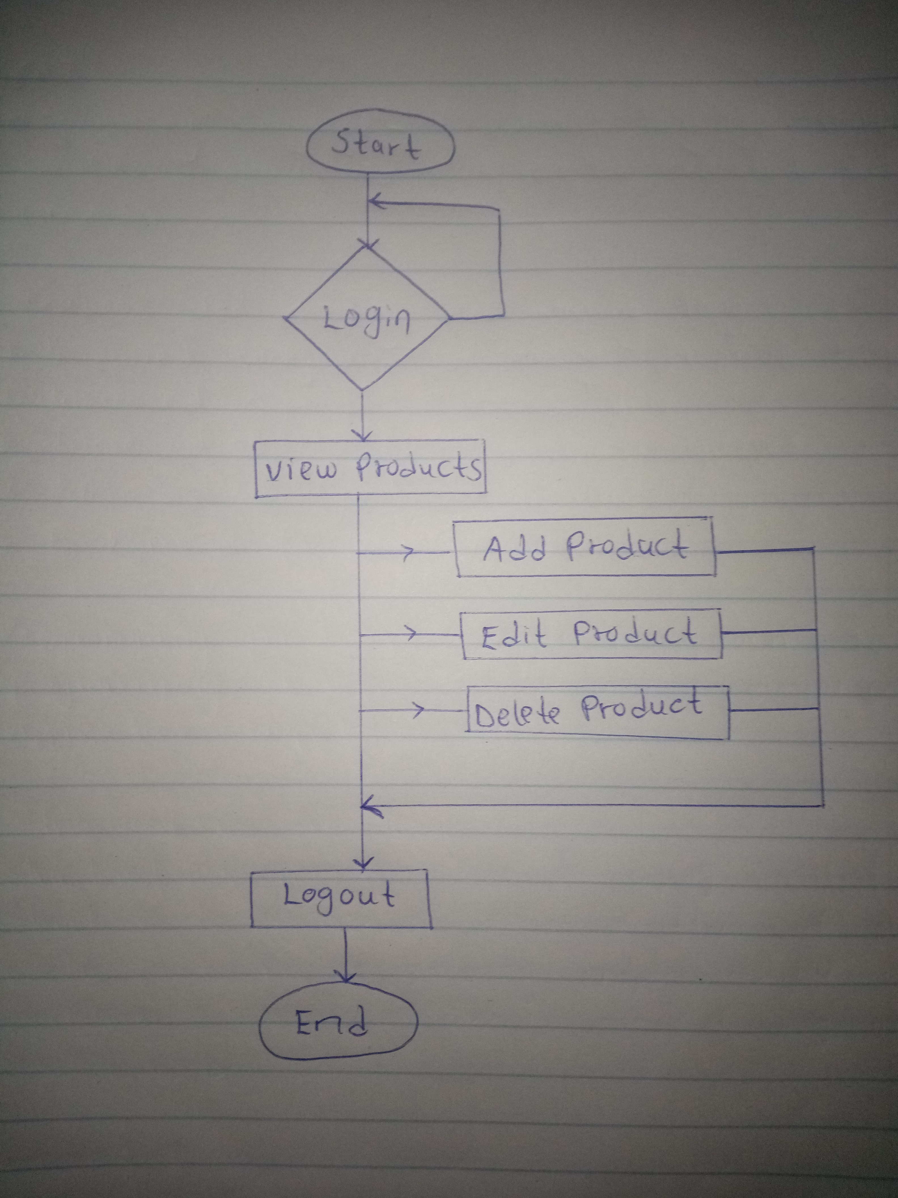

The admin will first need to login, then they’ll be able to add new products, view existing products, edit or delete products. They will be presented with a form to add a new product and an interface to view products, with the options to delete or edit. A logout button will also be presented.

Customer Flowchart

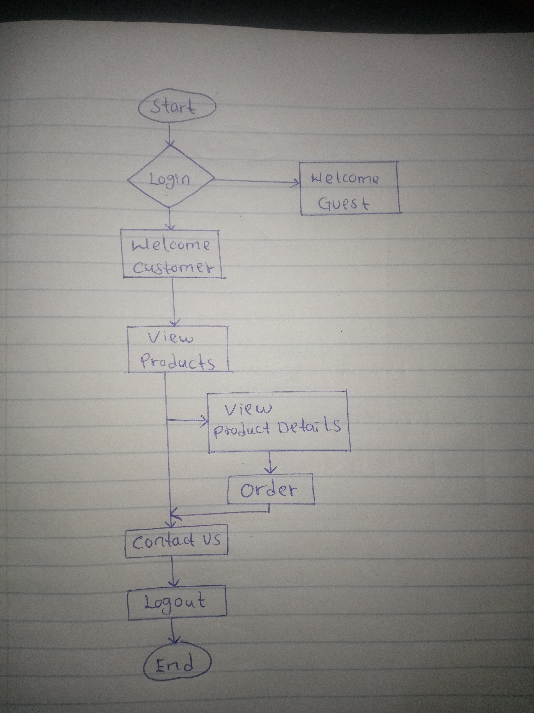

The customer can create an account but that is optional as the website allows guests to view products. The customer can then view the details of a product of their choice. If the customer decides to order the product, they will be redirected to the contact us page.

**Design Theme**

Contrast

We will use a material design theme with shadowed cards raised against a white background, to create a nice looking contrast between elements.

We will use a large font for headings and give them a different color. Also, the title, price and description of a product should have different font sizes.

Repetition

The following theme and colour scheme will be repeated throughout the website:

body background: #f0f0f0

main text colour: #333333

h3 font weight: 300

h3 font color: teal

button bg color: teal

button text color: white

Alignment

We divide the horizontal layout to a grid of 12 units, and use multiples of 3 or 4 for the width of all elements, to have a uniform alignment.

Proximity

Elements with one column will cover the entire content space horizontally, while elements with multiple columns will have uniform margins between them.

**Rough Sketches**

Landing Page

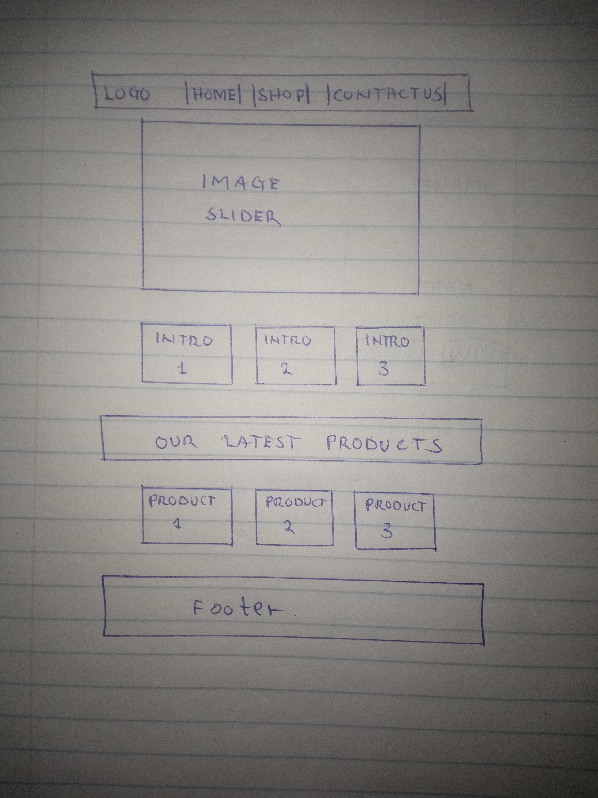

Product Card

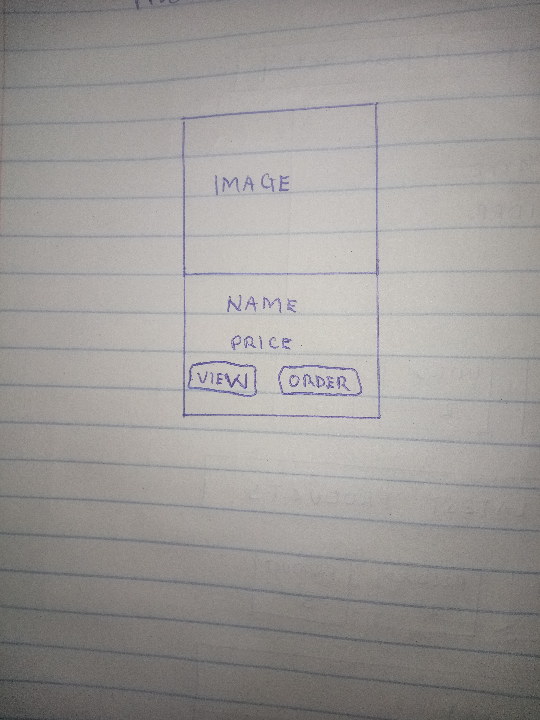

Product Details

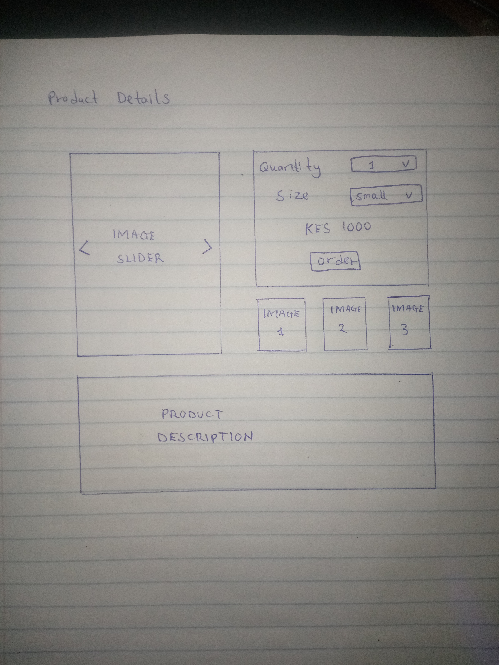

**Conclusion**

The above proposed plan should bring us close to our design goals. The different tasks will be divided among the team but we will work together to ensure consistency.